How to install the NI Software for FRC

1. Locate the NI Software for FRC packet, located near Mr. Hinckley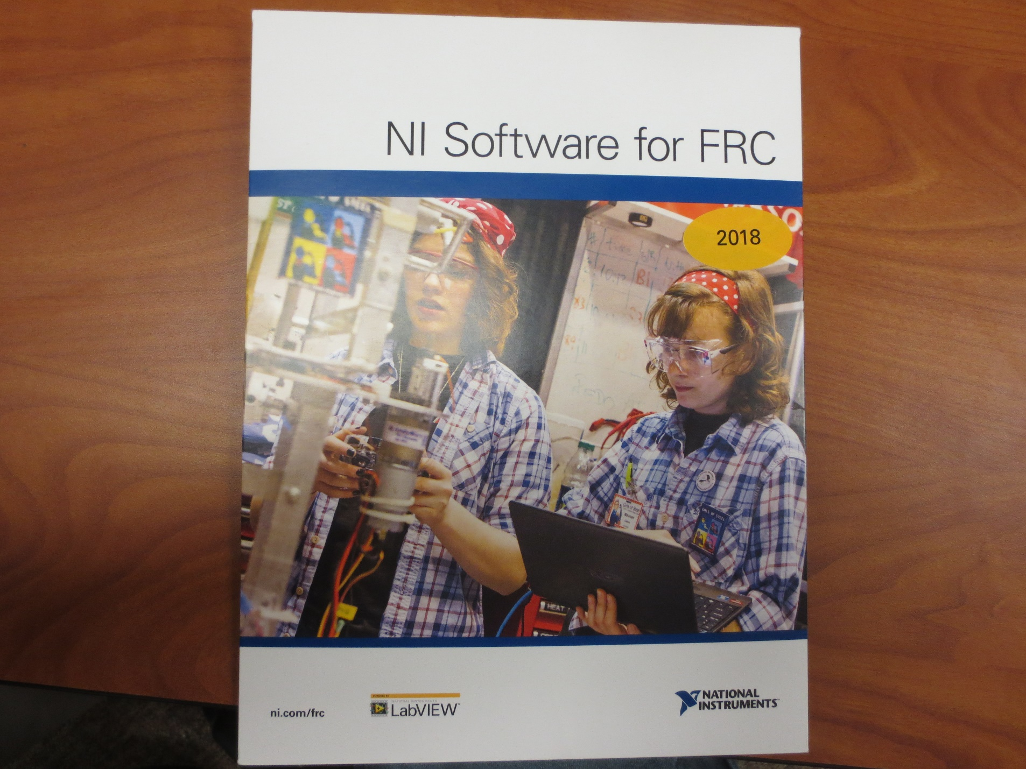
2. Inside locate the disc and insert it into your computer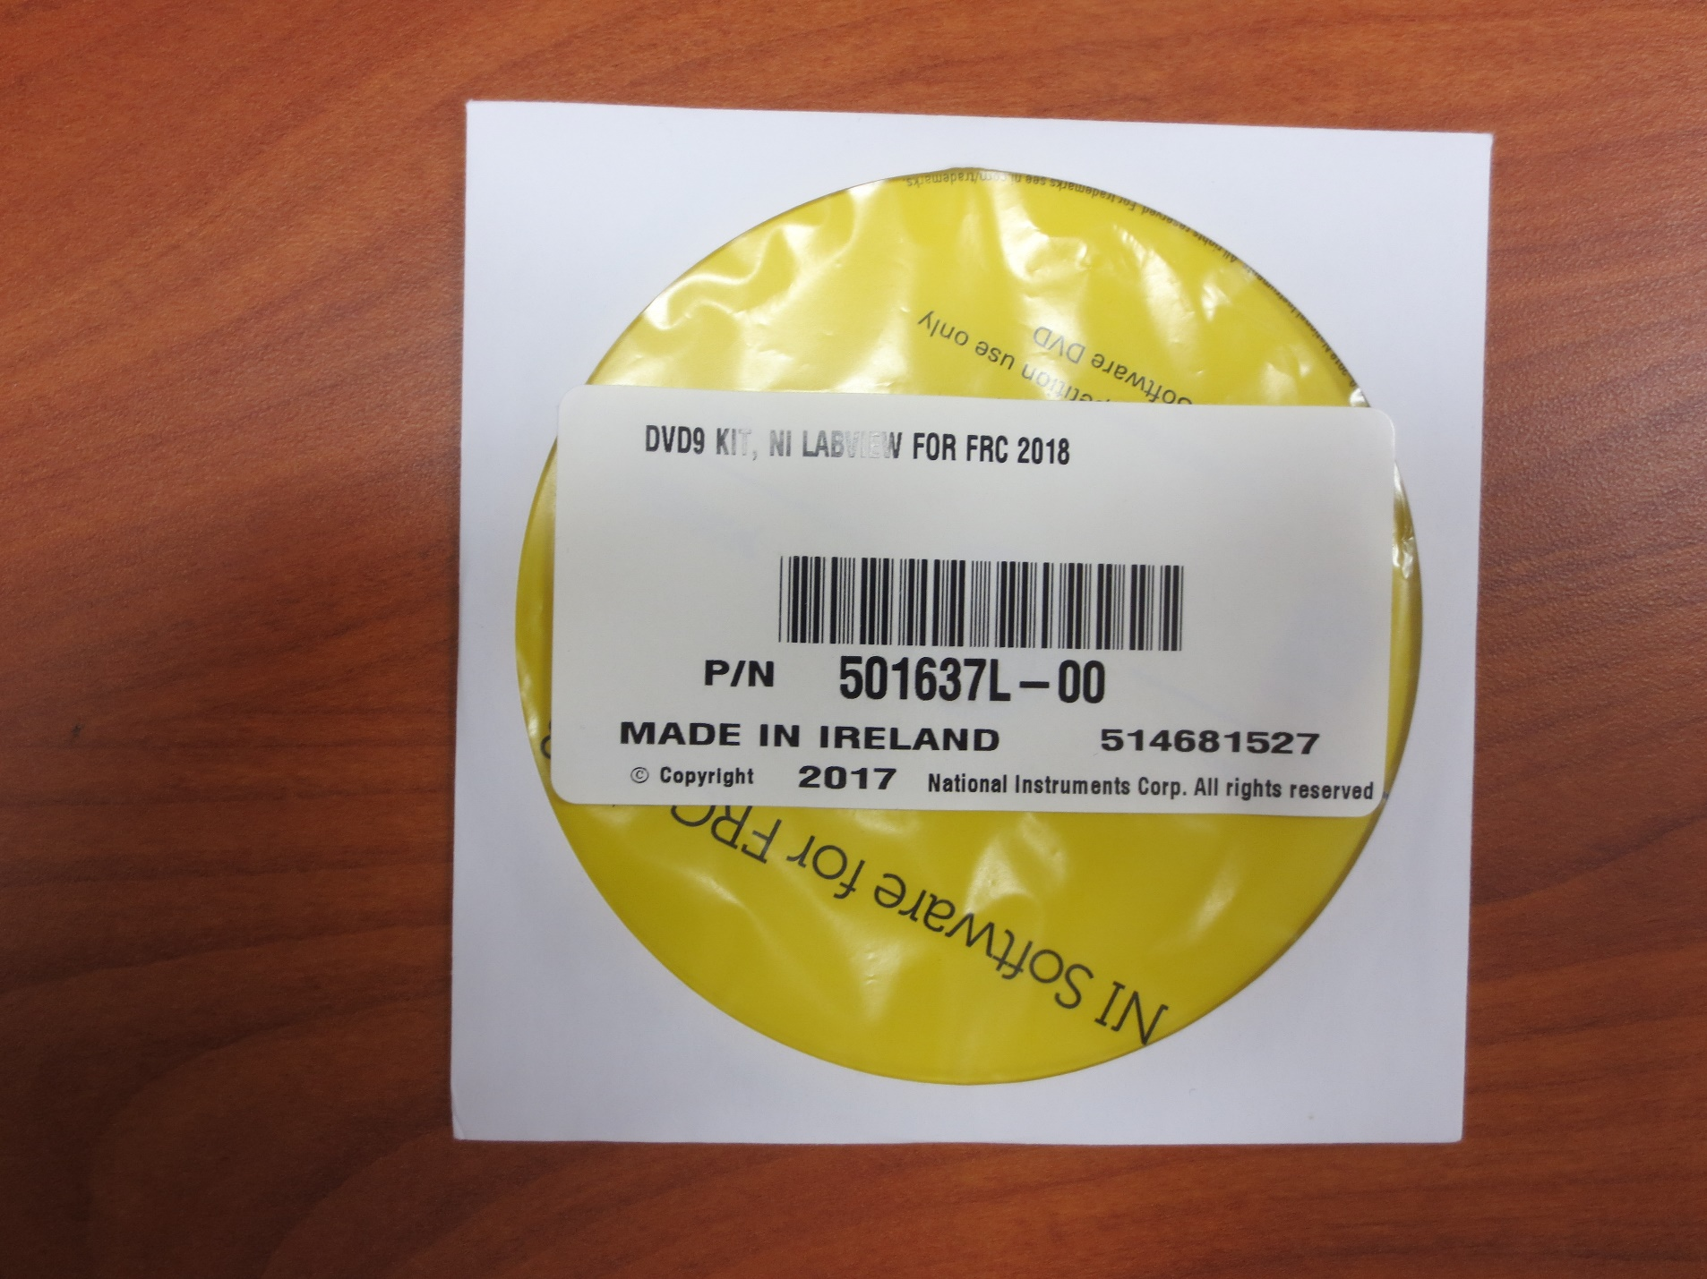
3. When prompted click Run autorun.exe
4. Click Install Only NI Vision Software (Magic Fingers required)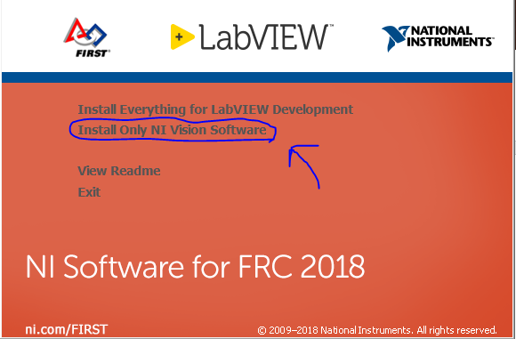
5. Continue clicking the next button until you get to the screen depicted below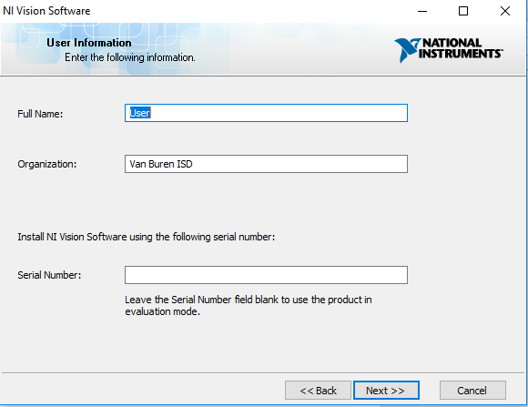
6. Retrieve the Certificate of Ownership located inside the packet where the disc was and insert the serial number into the text box labeled Serial Number: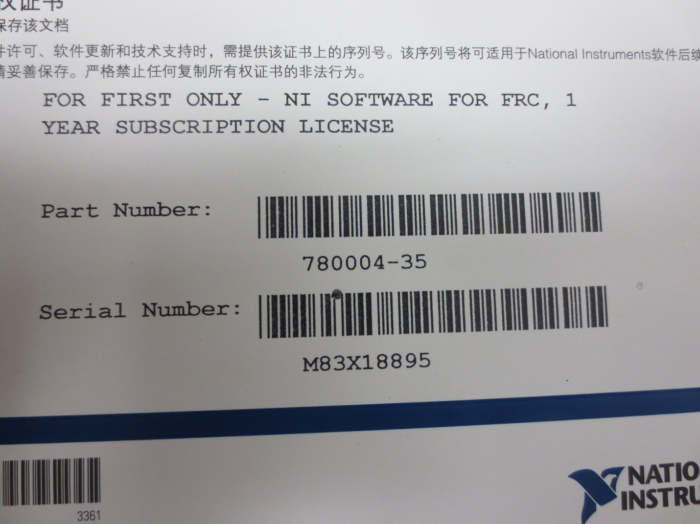
7. Be the liar you are and agree to having read and accepting all of the terms and conditions
8. Continue to click next until you get to the installation where you should wait patiently
9. Afterwards click next until finished